**UIPATH CITRIX AUTOMATION**

**VIRTUAL MACHINE**

Virtual machine is a guest operating system ,through a virtual machine manager like oracle virtual box,VMware etc.

GUEST OPERATING SYSTEM: Running mac/linux on the host operating system.

VIRTUAL MACHINE MANAGER: Like oracle virtual box.

HOST OS: Running windows.

**HOW VIRTUAL MACHINES GET AUTOMATED?**

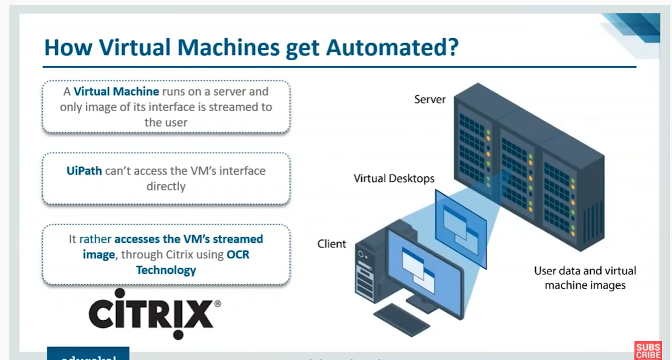

**WHY CITREX AUTOMATION**

Citrex provides remote access to the hosted resourses from a window server though its xenapp.

Uipath tool enable us to automated virtualized environment through citrex.